RBSGP EVENT INFORMATION
Event: Daily Mile Santa Dash
Date: Friday 8th December 2023
Time: 10:15 Registration 10:45 start
Venue: Queen's Park, Rochdale, Heywood OL10 4UY
The event will be approximately a 1 mile run or walk or combination around Queens Park, participants are encouraged to run or walk as much as they can and participate as part of a school group.

Team Composition: Participants can be from year 3 – 6 and can be mixed.
Bring as many children as you would like!
Fancy Dress/Christmas outfit/hat is encouraged and should be ‘Santa/Reindeer Themed’
but is NOT essential
Suggested 50p donation per participant, all monies should be collected in school and then will be donated to ‘Save the Children, UK’

Type of Competition: ENJOY
Aimed at….
Those negatively impacted by Covid-19 – missed out on high levels of activity
Regular School Team Players
Those who compete outside of school
Those who demonstrate a high level of competence and confidence
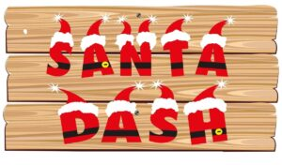

Staff: Staff are welcome to join in and are also actively encouraged to participate in the themed fancy dress

Entry: Through the Your School Games page

Dress: This event is inside please bring suitable clothing and medication that you may require.
Refreshments: Please ensure you bring something to drink as refreshments will not be available.
Cancellation policy: Please ensure you let us know if you can no longer attend so we can make the necessary alterations to the competition prior to the evening.

Terms & Conditions: Please ensure that you have read all the terms and conditions of the event above and, they are the conditions of our events and the venues which are allowing us to host.

Emma Mooney
School Games Manager
Rochdale Borough School Games

