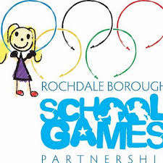

RBSGP EVENT INFORMATION

Event: Mini Olympics
The event will include lots of fun events, and will be run by Hopwood Hall College Students and RBSGP.
Date: Monday 12th February 2024
Venue: Hopwood Hall College (Middleton Campus) - Please meet at the Sports Arena
Time: 10:00 – 12:00am
Team Composition: The festival will be for a maximum of 6 x Y1 and 6 x Y2 children, there should be 3 boys and 3 girls in each year group (smaller numbers are also fine)
Type of Competition: Aimed at….
Non Engaged
Beginners/First Timers
Non competitive
Those who demonstrate a low level of competence and confidence or just want to
have a go.

Spectators: As this event is indoors NO SPECTATORS will be allowed.

Dress: This event is inside please bring suitable clothing, and medication that you may require.
Refreshments: Please ensure you bring something to drink as refreshments will not be available.
Cancellation policy: Please ensure you let us know if you can no longer attend so we can make the necessary alterations to the competition prior to the evening.

Emma Mooney
School Games Manager
Rochdale Borough School Games

